FUJIFILM

WHITE MT. IMAGING
Configuration and Setup Guide
FDX CONSOLE
(DR-ID 300CL)
03/20/2018

New Software Restore DVD for the HP
800G3 with V11.0 Software on Windows
10 64-bit for FDX Console (DR-ID 300CL.)

CONTENTS

1. Connecting the Peripheral Devices 2
2. Software Installation from the Restore CD 4
2.1 Verifying the BIOS Settings 4
2.2 Installation of the Restore CD 4
3. Post-Restoration Tasks 5
4. Installing and Programming the BCR (if applicable) 6
5. Check for Hot Fixes and ECN Updates 7
6. Software Standard Keys 7
7. Licensing……………………………………………………………………………………. 8

1. Connecting the Peripheral Devices
If the FDX Console will be used for D-EVO, start with Step 1. If the FDX Console will be used for CR (and does not have a second NIC included with the order), start with Step 3.
    - Remove the PC cover by sliding the access panel release lever to the right (1) so that it locks into place. Then slide the access panel back (2) and lift it off the computer (3). The cover may be difficult to remove. Be sure to place the PC on a sturdy surface while removing the cover to avoid damage and/or injury.
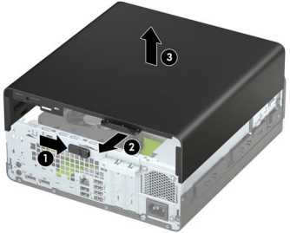

    - Install the included Network Adapter to the PCI slot closest to the power supply, and connect a second network cable to this adapter. This adapter will be used to connect to the hospital’s network. The plate covering the slot is not a slide plate, it is a punch plate. Remove with caution to avoid damage and/or injury.
    - Referring to the image and chart on the following page, connect the Keyboard and Mouse to the USB ports directly below the RJ-45 Network Connector (#7). Connect the DVI cable from the Elo monitor to the DVI to DisplayPort adapter and connect the DisplayPort adapter to the DisplayPort (#5) on the right side (closer to the VGA port, which will be in position #6). Connect the network cable to the RJ-45 port (#3). Connect the USB cable for the Elo touchscreen to the bottom USB port (#8). Do NOT connect the Serial cable for the Elo monitor, always use USB. Connect the power cord (#9).
Note: We recommend connecting the Elo monitor using the DVI cable in conjunction with the DVI to DisplayPort adapter. Do not use the VGA cable. If the Elo monitor did not have a DVI cable included, use the DisplayPort cable and save the DVI to DisplayPort adapter for use with another system.

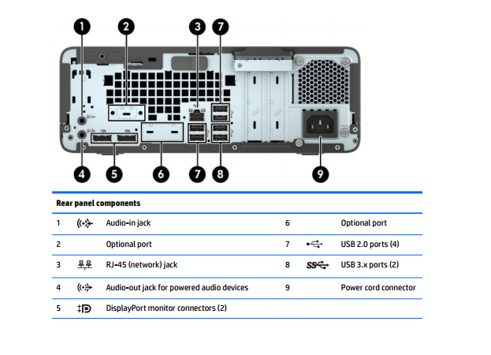
If you have trouble getting into the Bios, it can be accessed by
doing the following:

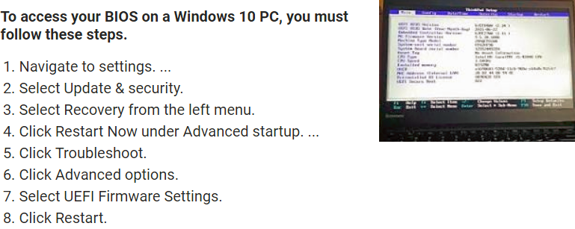

You will need the following:

Windows 10 64 bit Repair Disk
Fdx Console Software Restore Disk
DR-ID 1200 Application Software Disk (Optional)

2. Software Installation from the Restore CD

2.1 Verifying the BIOS Settings

    - Turn computer on and hold the [F10] key until the Computer Setup screen is displayed
(An alternative method of accessing the Bios can be found on pg. 3 of this booklet).
    - From the "Advanced” menu, select “Boot Options” and remove the check box for Network (PXE) Boot
    - Click the back arrow, then select “Built-In Device Options” and select “Boot to Hard Drive” from the drop down menu for the Wake On LAN setting
    - Click the back arrow, then select “Power Management Options”
    - Remove the checkbox from “PCI Express Power Management” and then click the back arrow
    - Click “Secure Boot Configuration” then select “Legacy Support Disable and Secure Boot Disable” from the “Configure Legacy Support and Secure Boot” pulldown then press the back arrow.
NOTE: Failure to set this setting correctly will result in the error “Password Last Set” during system
image restore.
    - Select “Remote Management Options” and remove the checkbox from “Active Management (AMT)”
    - Click the back arrow and then the escape key. Click Yes when prompted for saving changes.
    - The PC will be restarted
10. Confirm Secure Boot by entering the 4 digit code you see on the screen. (If you don’t enter this correctly,
restart the machine and recheck the bios settings then try again).
11. Repeatedly press, (Or hold) the [F9] key until the Boot Device screen is displayed.

2.2 Installation of the Restore CD

1. Insert the Windows 10 64 bit Repair Disk (800047076) into the DVD drive
2. Using the Up/Down arrow keys, select “UEFI – hp PLDS DVDRW” and press [Enter]
3. When prompted to “Press any key to boot to the DVD” press [Enter]

The Hp screen will show. Wait 5-6 minutes for the option screen
4. Click “US” at the “Choose your keyboard layout” screen
5. On the “Choose an option” screen click [Troubleshoot]
6. On the “Troubleshoot” screen click [Advanced options]
7. On the “Advanced options” screen click [Command Prompt]
8. In the Command Prompt window type “diskpart” and press [Enter]
9. At the DISKPART> prompt type “select disk 0” and press [Enter]
10. Disk 0 is now selected. At the next DISKPART> prompt type “clean” and press [Enter]
    - After “DiskPart succeeded in cleaning the disk” is displayed type “exit” and press [Enter]
    - At the command prompt type “exit” again to close the command prompt window
    - On the “Choose an option” screen click [Troubleshoot]
    - On the “Troubleshoot” screen click [Advanced options]
    - On the “Advanced options” screen click [System Image Recovery]
    - On the “System Image Recovery” screen click [Windows 10]
    - Eject the Windows 10 64 bit Repair Disk from the DVD drive, insert the FDX Console Software
Restore DVD, and click [Retry]
    - Click [Next >] after the system sees the restore image for fdxcsl
    - If available, place a checkmark in “Format and repartition disks”
      - This option will likely be greyed out and not clickable
    - Click [Next >], then click [Finish]
    - When prompted “Are you sure you want to continue?” click [Yes]
    - When restoration is complete, the PC will be rebooted automatically
    - Remove the Software Restore DVD from the drive after PC has restarted
    - Click [Restart Later] if prompted for another restart
    - Insert the DR-ID 1200 Application Software Disk
    - Start RU-Tool and delete the DR-ID 1200 V13 tool that is installed
(This is Optional if you have the disk)

3. Post-Restoration Tasks
1. Rename the on board NIC (usually named Ethernet) to “Eth0” and set its IP address in
accordance with the customer’s IT policy
      - The onboard NIC is called Intel® Ethernet Connection (5) I219-LM
2. Rename the second NIC (usually named Ethernet 1) to “Eth1” and set its IP address to 192.168.0.10,
with a subnet mask of 255.255.255.0
a) The second NIC is called Intel® Gigabit CT Desktop Adapter

Follow the FDX Console Licensing Procedure (SI 16-027) to obtain a license key
4. Installing and Programming the BCR (if applicable)

1. If the FDX Console will be used for CR, attach the Datalogic Gryphon barcode reader to an
available USB port on the rear panel of the PC
2. Right-click the Start button and select “Device Manager” from the menu
3. Expand the item named “Human Interface Devices” by clicking the “+" symbol next to it
4. Right-click the first entry in the list named “USB Input Device” and select “Update Driver Software”
5. Click [Browse my computer for driver software]
6. Click [Let me pick from a list of device drivers on my computer]
7. Select “WinUSB BCR (Datalogic Gryphon GD4130)” from the list and click [Next]
8. At the Windows Security prompt, click [Install this driver software anyway]
9. Click [Close] when the installation is complete
10. Verify proper installation as shown
11. Exit Device Manager, and referring to SI 15-013, perform programming of the Gryphon barcode reader
      - Do not perform Step 2 of SI 15-013 for Windows 10 systems
12. Restart the PC, allowing the FDX Console application to launch
13. Perform a test study, and check operation by verifying the Imaging Plate barcode appears in the barcode
field of the test menu
5. Check for Hot Fixes and ECN Updates
Check for any hot fixes and ECNs that have been released after the creation of the Windows Restore image,
and install as needed. The version of this restore image is V11.0.0001 The following hot fixes have been
installed and are included in this restore image.

6. Software Standard Keys 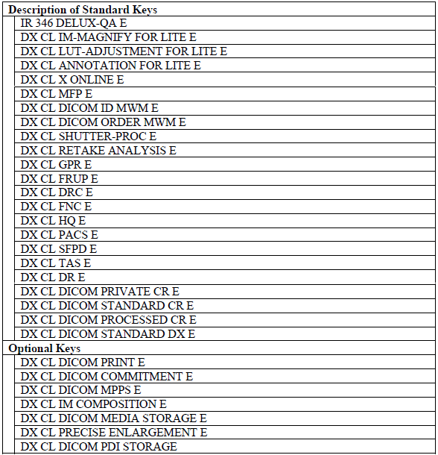

7. Licensing

After the Image process has been completed the application software will fail to launch due to
the licensing requirement. In order to request a License Key, the following information is required.
• Hardware Unique ID: (required)
To obtain the Hardware Unique ID, open Service Utility > License Tool > Activation
• Site/Clinic Name: If available, otherwise enter Dealer Name here
• Comments: Any relevant site specific notes
• PC Serial Number: (required)
• Access Number: (required for new installations, enter one per line)
With this information ready, call TAC at 1 (800) 272-8465, or email your request to
fmsumodalitysupport@fujifilm.com
To activate the software after receiving a License Key, open Service Utility > License Tool >
activation and import the .key file provided by TAC.
This is a SAMPLE of a request to Fuji for a License. the standard 6 keys as well as the 2 MWL keys.

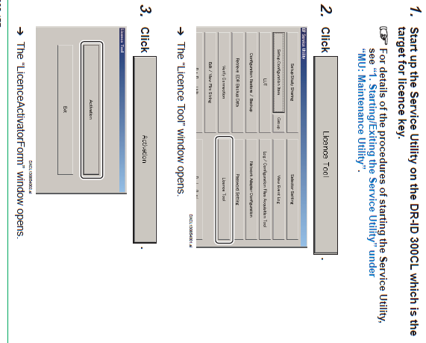
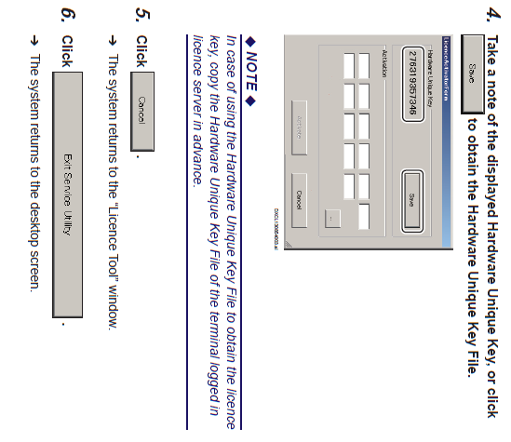
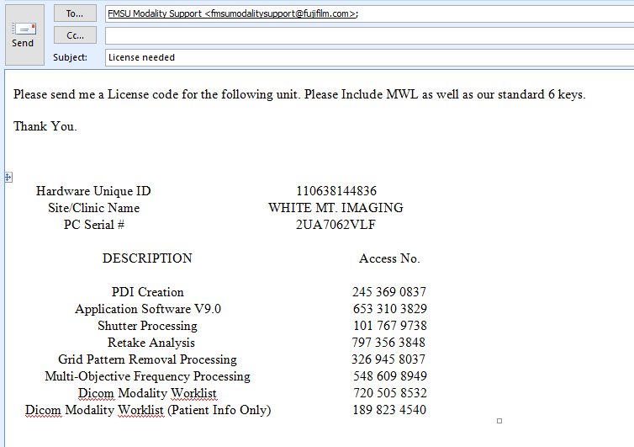 The description and access numbers are on your yellow envelopes. The first 6 are our standard keys.
This is a SAMPLE of a request to Fuji for a License. It has the standard 6 keys as well as the 2 MWL keys.
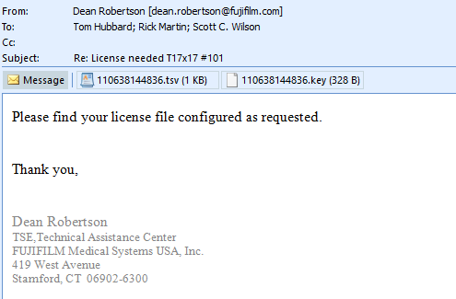
This is a reply from Fuji, with the Key file (activation code) and a tsv file which explains what’s been activated.
This is a reply from Fuji. It has the key file which is your activation code and a tsv file which should list everything that is activated with that code. Put the Key file on a Thumb drive. Now go back to the License Tool and instead of saving the UID, click the […] and point to the drive with the Key file. Click activate and the code should fill in the blanks. Click ok and exit the application.

